Dominic Carr 11/28/2025
Individual Portfolio Page
Objective of the project:  The objective of this project was to create a carnival game that incorporated an engineering failure. The engineering failure that our group chose was the St. Francis Dam collapse in California. To demonstrate this engineering failure our group used photoresistors and LEDs to act as critical weak points. To stop the dam from collapsing the user must hit each critical point when the LED turns on with a laser pointer. If the person fails to hit a certain number of targets, then the servos will turn and the doors will release the marbles. Even though our group was faced with many obstacles, we all worked collaboratively and communicated to finish the project in a timely manner. | 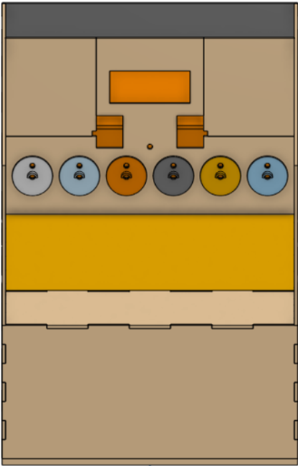  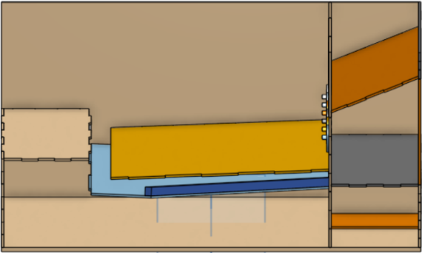  On Shape Design:
Components I made:  - Structural components  - Constructed a durable project  - Covered the wiring  - Assembled project from laser cut components and 3D printed parts  - Mechanical components  - I attached the doors of the dam  - Accounted for the weight of the marbles  - Created consistent movement from the servos | Structural Components of the project:  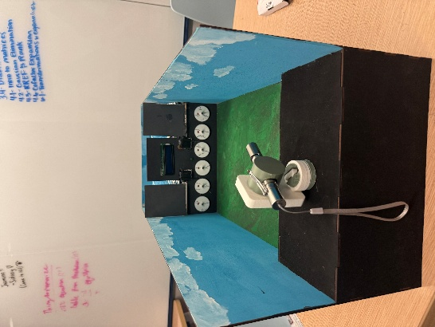  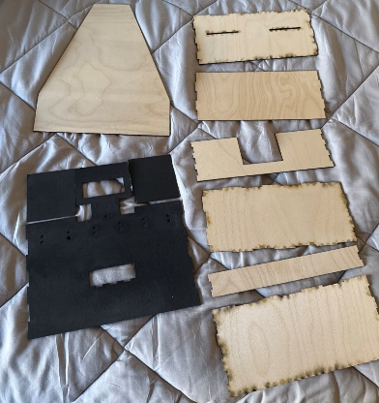
Skills that the components demonstrate:  - Design, AutoCAD, Laser cutting, and physical construction  To complete the structural components, I needed to make sure all the laser cut components fit with each other from the On Shape and AutoCAD design.  - Problem solving, Communication, Creativity, and Knowledge of physics  To complete the mechanical components, I needed to examine the weight distribution, torque, and support of the door when the user lost the game and the door opened/rotated. | 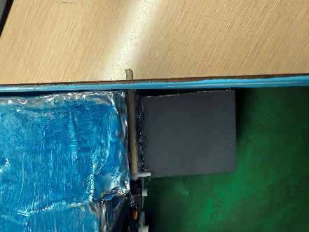  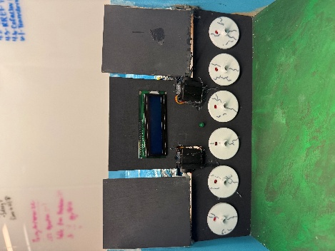  Mechanical components of the door:

